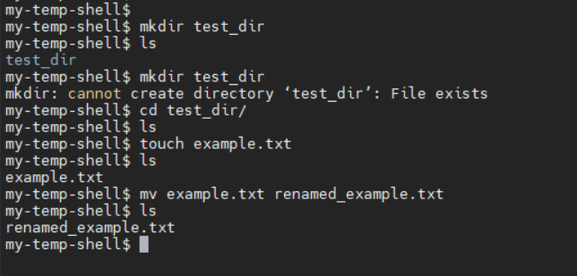
- File & Directory Management
  - Created directory using `mkdir`
  - Created file using `touch`
  - Renamed file using `mv`
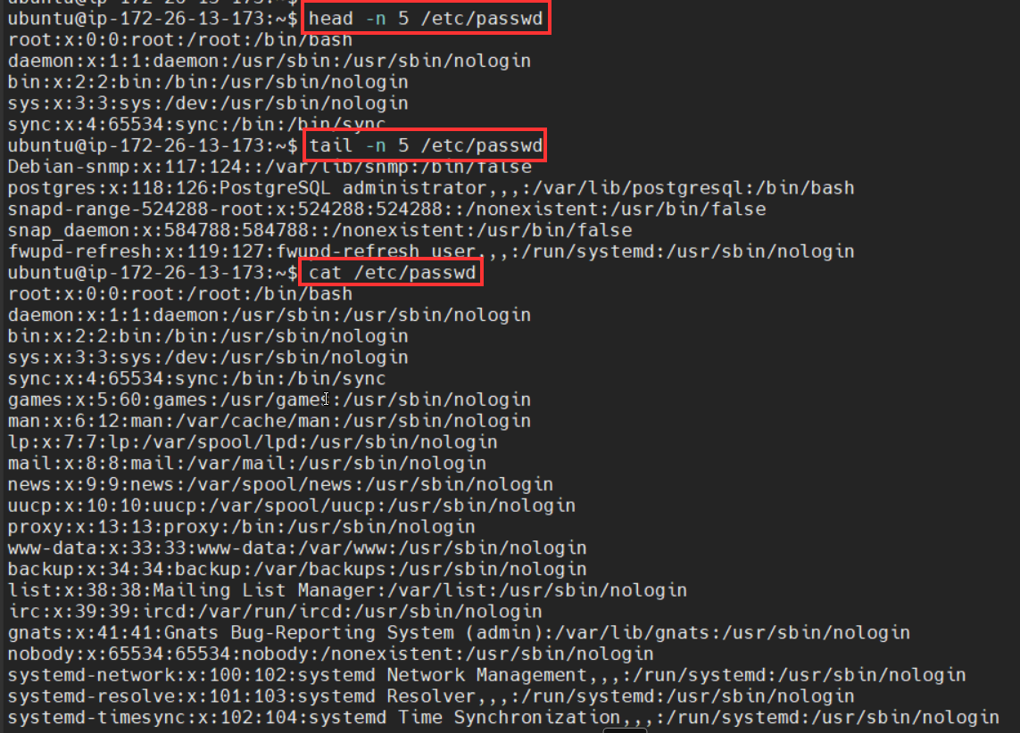
- File Content Viewing
  - Used `cat`, `head`, and `tail` to view file contents

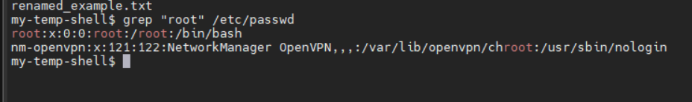
- Pattern Searching
  - Used `grep` to find specific patterns
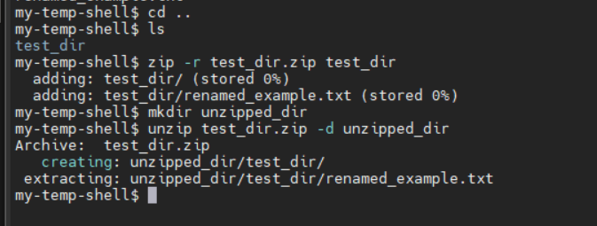
- Compression
  - Compressed using `zip`
  - Extracted using `unzip`
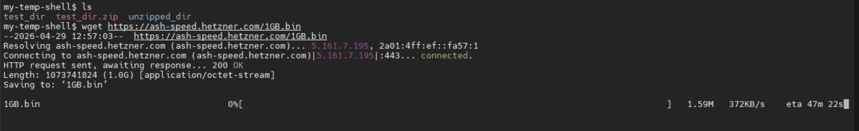
- File Download
  - Downloaded file using `wget`
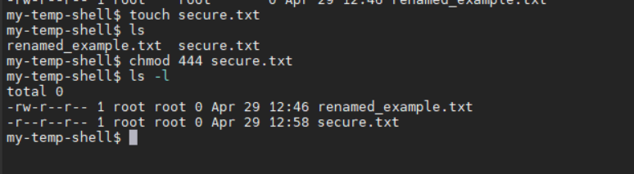
- Permissions
  - Changed file permissions using `chmod`
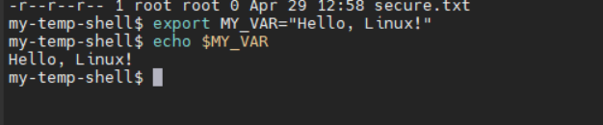
- Environment Variables
  - Created environment variable using `export`

